 DUM DUM EX-SERVICEMAN ORGANISATION.
Durganagar, Jana path Road,PO-Rabindranagar, Kolkata-700065.
Contact NO:-9836001866 / 9830651640.
E-Mail ID: ddeokol@yahoo.com / info@ddeokol.co.in
Website: www.ddeokol.co.in

COMPANY PROFILE

BACKGROUND AND HISTORY
The company is run by retired ex-serviceman group those who are utilised for smooth functioning of DUM DUM EX-SERVICEMAN ORGANISATION. The defence personnel are dedicated lot, disciplined and devoted to duties and their inherent qualities of honesty, integrity and spirit-de-corps will result in achieving the very high standard to maintain the present day Residential complexes/ Multiplex/ Commercial complexes and Industries for security & Vertical rescue & Safety management in high constructional industries & Buildings as well as all type man power service. We carry our training of our employees at our Durganagar office cum training school and on job training on regular basis.
Our Mission:
To give everyone power to create and share ideas and information instantly without barriers and improving people’s life through meaningful innovation.
Our deepest purpose as an Organisation is helping support the health, well being and healing of both people-customers, Team members and Business Organisation in general and the Planet.
Our Vision:
DUM DUM EX-SERVICEMAN ORGANISATION is the only company in west Bengal govern by different talented ex defence person are gather together & formed the pillar of success. DDEO are dedicated to creating a workplace that respects and values people from diverse background and enables all employees to do their best work. It is an inclusive environment where the unique combination of talents, experiences and perspectives of each employee makes our business success possible. Respecting the individual means ensuring that the workplace is free of discrimination and harassment. Our commitment to equal employment and diversity is a global one as we serve customers and employ people around the world. We see it as a business imperative that is essential to thriving in a completive global market place.
Our Target:
Teaming up for stronger and safe community.

CLIENT SERVICING:
In order to ensure a standard of service, which is of the highest order, a senior manager will be in a constant touch with your organisation.
SUPERVISION:
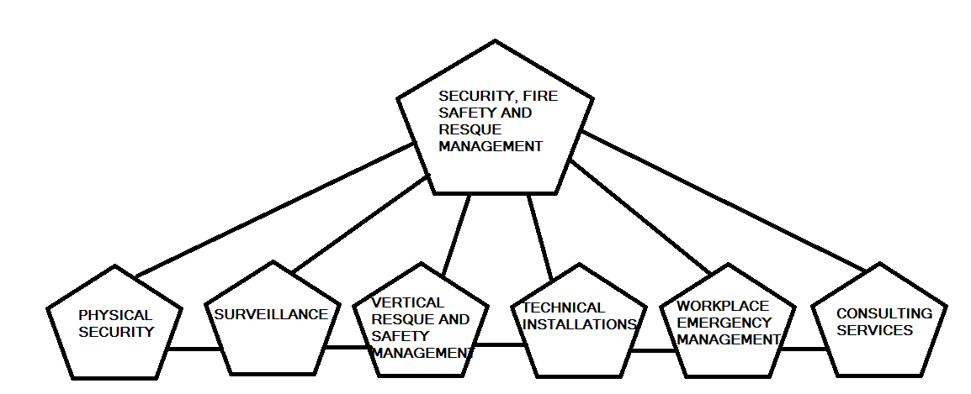
We believe that dedicated supervision is the hallmark of quality. Towards this aims all our assignment are checked by our trainer & company director day to day for upgrade with radio communication and mobile phone & by inspecting the project or by consulting with the Employer. Beside this patrolling officers and trainer are the back born of our guarding/ rescue operation and they also interact very closely with the guard / rescue officer and all type of man power service on the field and find out there problem and resolve them immediately.
- Manned Guarding
- Access and Admission Control.
- Monitoring (CCTV)
- Fall Arrest.
- Fire & Gas Detection and Fire Man service.
- Security service.
- Burglary Detecting.
- Communication Analysis.
- Vertical Rescue
- Alarm response & Emergency Evacuation.
- Mobile Patrolling.
- Car parking management.
- Visitor Escorting.
- Security Training.

PHYSICAL SECURITY & VERTICAL RESCUE TRAINING DIVISION
DDEO established a Physical Security & Vertical Rescue Training Division at the start of 2013. The purpose of the PSVRTD is to provide site surveys necessary to provide clients with an in-depth review of physical security & Rescue procedures and review of Emergency Implementation Plan and security guard readiness & Rescue operation.

SUBJECT: PROFILE
Dear Sir,
- DUM DUM EX-SERVICEMAN ORGANISATION offer the top quality security, Facility & HR management, Rescue Operations and Safety Managements services to our revered clients at most competitive rates. We are also pleased to offer you ex-defence personnel/civil guard/rescue officers according to your requirements. This is based on a dynamic cost effecting planning and management system backed by a very professional dedicated experienced management, technical work force. The aim is to provide quality services.
- Since the Company is run by numbers of retired Defence personnel are utilized for the smooth functioning. The Defence personnel are a dedicated lot, disciplined and devoted to duty and their inherent qualities of honesty, integrity and spirit-de-corps will result in achieving the very high standards required to maintain the present day Residential complexes/ Mines/ Multiplexes/ Commercial complexes / Industrial safety, rescue and high-rise construction and all type of man power service. We carry out training of our employees at our Durganagar office on regular basis.
- The rates will be competitive to suit your requirement and the overheads will be minimum which will cut down the costs but the efficiency of maintaining the facilities will not be compromised. We will be dealing directly so that overheads cost will be minimized and competitive.
- The company has its Training Team in place and carries out its training activities at their training centre in Duganagar, Kolkata – 700 065.
- Please feel free to call us for further clarification in this regard if any.

Thanking you, with best regards,
DUM DUM EX-SERVICEMAN ORGANISATION.

Company Details
Sl.No | Description | Details
1 | Name of the Company/Organisation | COMPANY NAME-_____________________________________
2 | Type of Company | Partner Ship
3 | Address for Communication
 | Registered office address | Vivekananda Pally, P.O-Rabindra Nagar,Kolkata-700065
 | City office address | Jana path Road, West Durganagar, Kolkata-700065
4 | Contact Details
 | Mobile Number | 9830651640 /9836001866
 | E-mail address | info@ddeokol.co.in / ddeokol@yahoo.com
 | Website | www.ddeokol.co.in
5 | Board of Directors
 | Name | Contact No
 | Mr.Sudip Dey Sarkar | 9830651640
 | Mr.Rajkumar Sur | 9883237078
 | Mr.Poritosh Kumar Dutta | 9836001157
 | Mr.Tapan Kumar Mondal | 9874776279
6 | Statutory Compliance Information
 | PAN NO | AAJFD6167H
 | GSTIN | 19AAJFD6176H2Z1
 | PF Registration No | WB-CAL-1320079000
 | ESIC registration No | 40000441090000900
 | TAN No | CALD10410B
7 | Corporate Member ship No of National safety Council | CM-WB-383

OUR SERVICES

Following are the services offered by us: -

- Security management Services
- Water Treatment Plant management
- Housekeeping and hospitality
- Horticulture
- Quick response team
- Pest control
- Payroll management
- Fire fighting and systems management
- Travel and Event security management
- Executive Protection services (with arms / without arms)
- Vertical rescue management
- Industrial safety management
Our Supervision would facilitate

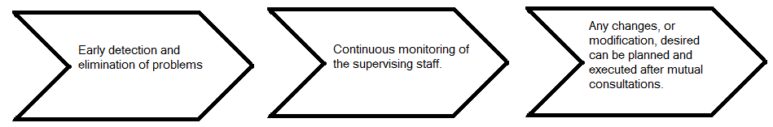

OUR CLIENTS
Some of our existing esteemed clients are as follows:-
ACC JAMUL PROJECT | ACC JAMUL PROJECT RAIPUR (RESCUE OFFICERS)
ACC JAMUL PROJECT | ACC JAMULPROJECT DHANBAD (RESCUE OFFICERS)
VOCATIONAL REHABILITATION CENTER FOR HANDICAPPED(GOVT. OF INDIA) | VRC KOLKATA, SALT LAKE CITY  (MAN POWER SERVICE)
TIRATH PROJECT(CONSTRUCTION) | LAKE TOWN, KOLKATA  (SECURITY GUARD SERVICE)
JAIRAM METAL | MADHYAMGRAM  (FIRE & SAFETY OFFICER)
CHARNAK HOSPITAL | KOLKATA  (MAN POWER SERVICE)
ROHRA DEVELOPER PVT.LTD. | LAKE TOWN, KOLKATA  (SECURITY GUARD SERVICE)
SHUSRUSHA NURSING HOME | KOLKATA  (MAN POWER SERVICE)
DR.RADDY’S FPONDATION | SALT LAKE, SEC-V  (MAN POWER SERVICE FOR BACK OFFICE)
SUNILI LEARHERN PVT.LTD | DUM DUM CANTT. GORABAZAR.  ( SECURITY GUARD SERVICE)

TRAINING

We are very much strict with the training department of our organization. We have a team of experienced ex-service men and soft skills trainers for effective training and recruitment. Since we consider training to be a very important part of our industry. All our training activities are handled by this company.
We have training academies at the following area:-

West Bengal: - One training centre in Kolkata. There is a capacity of 50 students per month. We are absorbing 100% of manpower from this centre.

The company has decided to spend 5 to 10 lakhs in the next 2 years on the development of training infrastructure as part of the company’s commitment to strive for better client servicing and satisfaction.

PERFORMANCE OF RESCUE OFFICERS
1. Responsibility of Rescue management
2. Recognise Unsafe Condition
3. Shop Safety
4. Care for the Injury
5. Accident / Incident Report
6. Keeping in Shape
7. Proper Lifting
8. Horseplay
9. Protecting the Public
10. Vehicle Operation
11. Traffic Control
12. Barricades and Warning System
13. Weather Effects
14. Self Safety Protection
15. Housekeeping
16. Storage
17. Material Handling
19. Signalling Technique
20. Handling Tools / Electrical Tools
21. Guard Rail, Ramp and Runway
22. Excavation, Trenching
23. Working Confine Space
24. Working Around Crain
25. Fire Protection and Control
26. Personal Protective Equipments
27. Tool Box Task
28. First Aid

PERFORMENCE OF FIRE & SAFETY PERSONEL

- Fire Drill
- Maintenance of Fire Cylinder & Fire Equipments.
- Maintenance of Fire Tender, Vehicle.
- Operation of Fire Tender.
- Operation of Industrial Fire warning system including Hydrant operation.
- Cordoning of Fire.
- Excavation.

OUR VERTICAL RESCUE TRAINING SESSION
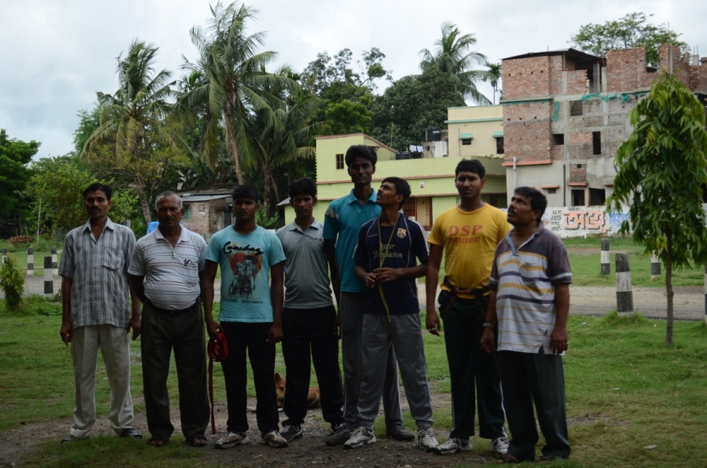
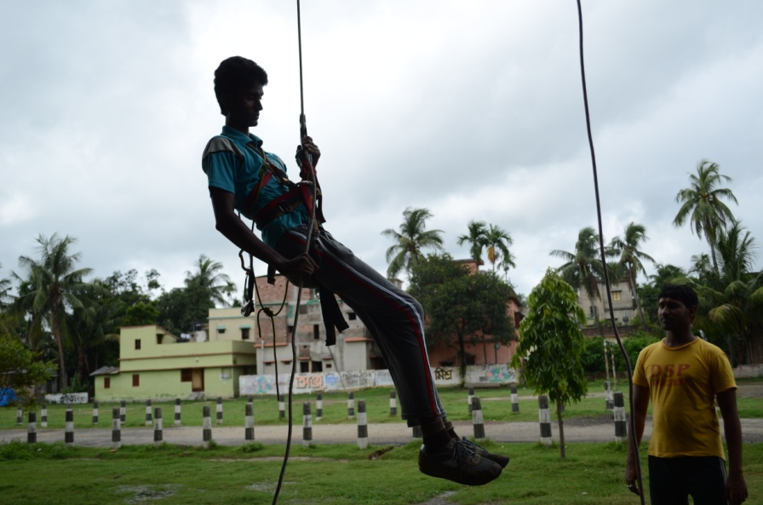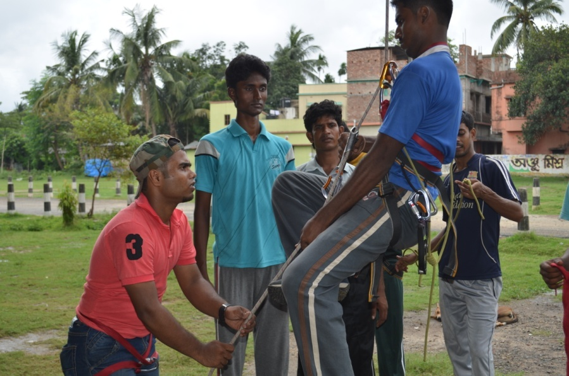
Our rescuer working at acc Jamul project Raipur.
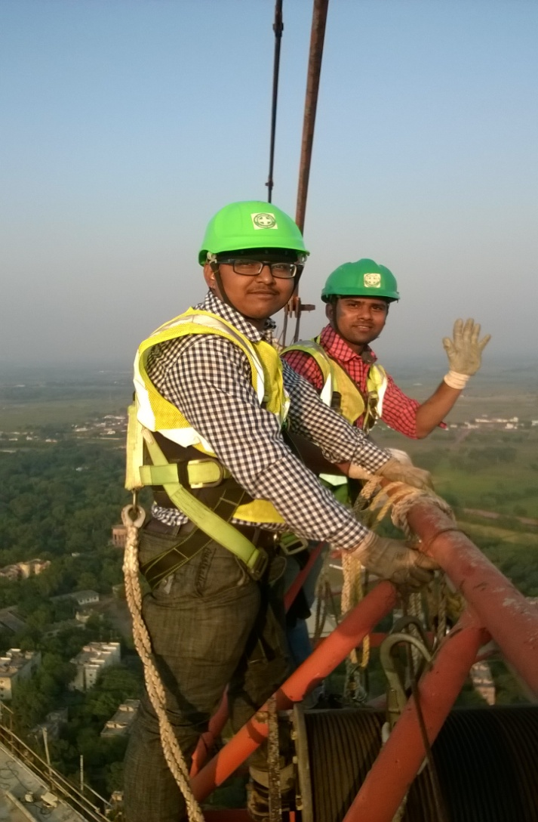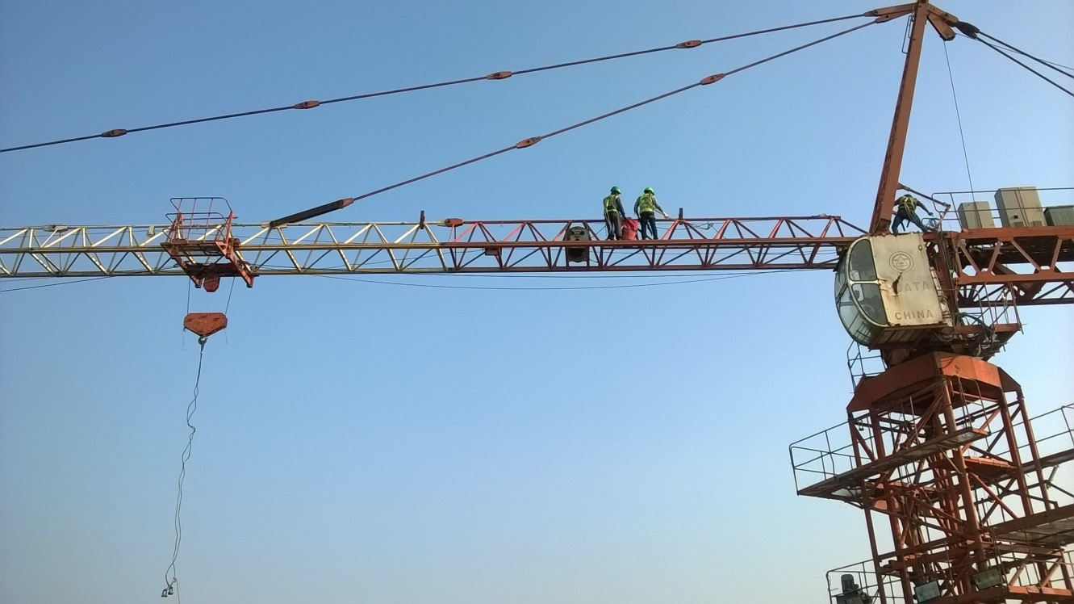

Sub : Proposal Letter.

Dear Sir,

This is only organization which is run by ex-military group those are trained and served for at least twenty years in Indian defence (Army, Air Force, Navy). We got own training school to train the civil / ex-serviceman for security guard / firemen / rescue officer / constructional safety officer in our organization which is very essential and support of a Industrial infrastructural progress.

We are sending the proposal to you for your kind consideration and favourable action please.

We are working for a socio economic reform throughout India to train the bellow poverty educated students, so that their economic structure may be develop by some fruitful means. your support can provide us to develop the nation poverty.

We expect a good support from your side.

With regards,

Sudip Dey Sarkar
(Director)
DUM DUM EX-SERVICEMAN ORGANISATION.

